
DEPARTMENT OF COMPUTER SCIENCE COS5019-B ENTERPRISE PRO

Requirements and Specification Document
for
ShopQuick – AI-Driven Grocery Savings Assistant
(Project 3, P3)

Prepared by Team 4
Name | Role | UOB Email | UOB Number
Maryam Haroon | Team Leader | mharoon9@bradford.ac.uk | 23010607
Mahnoor Shahzadi | Team Speaker | mshahz28@bradford.ac.uk | 24001844
Aliya Rashid | Team Secretary | arashid49@bradford.ac.uk | 24007870
Kainat Yasin | Member | kyasin3@bradford.ac.uk | 24010749
Lazhary Elazhari | Member | l.m.s.elazhari@bradford.ac.uk | 24002640
Armaan Tanweer | Member | atanweer@bradford.ac.uk | 24004033

Project Name: P3 ShopQuick – AI-Driven Grocery Savings Assistant
Client Name/address: a.ainamarshall@icloud.com
Team Name/Number: Team 4
Document Version: 1.0
Date: 12/03/2026
Authors
Name | Role | UOB Email | UOB Number
Maryam Haroon | Team Leader | mharoon9@bradford.ac.uk | 23010607
Mahnoor Shahzadi | Team Speaker | mshahz28@bradford.ac.uk | 24001844
Aliya Rashid | Team Secretary | arashid49@bradford.ac.uk | 24007870
Kainat Yasin | Member | kyasin3@bradford.ac.uk | 24010749
Lazhary Elazhari | Member | l.m.s.elazhari@bradford.ac.uk | 24002640
Armaan Tanweer | Member | atanweer@bradford.ac.uk | 24004033

Document History

Version | Date | Author | Changes Made / Summary of Updates | Approved By

Table of Contents
1. Introduction
1.1 Purpose and Scope of the Document
1.2 Project Overview
1.3 Scope of the Document
1.4 Related Documents
1.5 Definitions and Acronyms
1.6 Assumptions and Risks
2. Team Expertise and Rationale
2.1 Team Skills and Experience
2.2 Rationale for Project Choice
3. System Overview
3.1 System Context
3.2 UML Activity Diagram
3.3 UML Sequence Diagram
3.4 System Actors and Roles
3.5 Dependencies and Impacts
4. Functional Specifications
4.1 High-Level Functionalities
4.2 Use Cases
4.3 Functional Requirements
4.4 UML Use Case Diagram
4.5 Testing / Acceptance Criteria
5. Non-Functional Requirements
5.1 Performance Requirements
5.2 Security Requirements
5.3 Usability Requirements
5.4 Availability / Reliability Requirements
5.5 Additional Non-Functional Requirements
5.6 Testing / Acceptance Criteria
6. Data and Reporting Requirements
6.1 Data Sources
6.2 Data Structures and Entities
6.3 Database Design and ER Diagram
6.4 Data Flow Description
7. User Interface Design
7.1 Interface Overview
7.2 Interface Layout
8. Work Plan and Project Management
8.1 Project Development Methodology
8.2 Project Timeline and Gantt Chart
9. Legal Social, Ethical, and Professional Issues (LSEPI)
9.1 Legal Considerations
9.2 Ethical Considerations
9.3 Social Impact
9.4 Security Considerations
9.5 Professional Responsibilities
9.6 Environmental Considerations
9.7 Risk Assessment
9.8 Economic Considerations
10. Data Migration / Conversion (if applicable)
10.1 Strategy
10.2 Preparation
10.3 Conversion Rules
11. Open Issues / Questions
12. References
13. Appendices

Introduction

Purpose and Scope of the Document
The document defines the system specification for the ShopQuick AI-Driven Grocery Savings Assistant. It provides a comprehensive description of the system's objectives, functional and non-functional requirements, constraints, data specifications and design considerations. The document serves as a guide to understanding and developing the required system features and functionalities, and it also acts as a reference for testing all specified requirements. By clearly outlining system requirements and expected behaviours, the document ensures consistency and reduces ambiguity during development, implementation and evaluation.

Project Overview
The primary objective of this project is to develop a web-based application that demonstrates the core workflow of the ShopQuick AI agent. The web-based application will operate using product and store datasets to simulate realistic functionality. The intended benefits of the system include helping users make informed, budget-friendly grocery decisions, demonstrating the feasibility of an AI-driven price comparison model, and showcasing an intuitive conversational user experience.

Scope of the Document
The document includes a description of the system's objectives, system architecture overview, functional and non-functional requirements, and any additional features suggested by the client. However, the document will not incorporate real-time supermarket integration, live payments or checkout systems. The main focus is on developing a structured and interactive AI model that delivers effective and inexpensive solutions according to the user's needs.

Related Documents
The following documents are related to this specification:
- Client project brief
- NDA
- Peer Review
- GitHub repository

Definitions and Acronyms
The document includes the following definitions and acronyms:

Artificial Intelligence (AI)
A system capable of simulating intelligent behaviour, such as understanding user input and generating recommendations.

Optical Character Recognition (OCR)
A technology for extracting text from images.

General Data Protection Regulation (GDPR)
The law governing data privacy and security standards for processing individuals’ personal information.

Synthetic Data
An artificially generated data intended to reflect real-world data.
Provide definitions of key terms and acronyms used in the document.

Password Hashing
A security practice where passwords are transformed into encrypted representations before being stored in the database.
User Interface (UI)
The visual elements by which the user and a computer system interact, in particular, the layout, design, hardware and software.

Assumptions and Risks
The system involved has its restrictions and risks. This includes the system operating on synthetic data, rather than live supermarket data or external APIs. However, this entails the risk that the data will not realistically reflect the real-world supermarket variability, and the AI responses will rely on the original database. Furthermore, as the system is implemented as a web application, it can only be accessed by users through modern web browsers. And the system also relies on users to provide accurate information about their expectations and requirements, which can pose a potential risk of mishandling user data and violating the GDPR laws. Therefore, improper implementation of safety measures, such as password hashing, could compromise user privacy and data security.

Team Expertise and Rationale

Team Skills and Experience
Our team is multi-skilled, with professional experience in web development, including members who are creative and highly skilled in front-end web design and applied AI concepts. We are motivated to build innovative solutions that address real-world, industry-level problems, which is what has drawn us to the ShopQuick project.

Rationale for Project Choice
Creating an AI agent that translates a user’s budget and requirements into the most efficient shopping options strongly aligns with our interest in practical AI and clean, intuitive interface design. Through this project, we will further develop our skills and demonstrate our technical ability to write efficient logic, while also applying our creative problem-solving abilities. Our goal is to use AI in a reliable and responsible way to make everyday life more convenient and affordable for users.

System Overview

System Context
ShopQuick is a web-based shopping assistant that allows users to interact with an AI agent to get personalised and budget-friendly shopping recommendations. To enhance personalisation, a login feature is provided to enable the AI agent to track preferences and dietary requirements from chat history, which is also a convenient feature for users to monitor their conversations. The user can input text or speech to provide information on their requirements and budget, and the system calculates the cheapest stores to fulfil their shopping list. The AI calculation feature is built using synthetic data that resembles popular supermarket products and prices, helping to identify suitable products that match the user’s shopping list. After successfully recommending the most cost-effective shopping plan, the system will prompt the user to share and promote the application on social media. Additionally, the user can contribute to the system’s data collection by uploading images of receipts, which the system will scan and convert to text-based data.

The ShopQuick system uses HTML and CSS to format all the different web pages. And the frontend and backend are connected using a Flask framework. The receipt scanner uses the pytesseract module which is an interface for the OCR engine to detect meaningful information from the receipts. It utilises contour edge detection, to detect the four corners of the receipt, and then uses psm 6 ( age segmentation mode 6) which treats the receipt as a single block of text, improving accuracy. Regular Expressions (Regex) is the tool used for pattern matching and text manipulation. Therefore, the Regex is used to filter out, store name, prices, and item names from the receipt, further fields such as postcode and city can be manually added by the user. The chatbot uses spaCY which is a Natural Language Processing (NLP) model to detect useful information from the user input, the AI agent then goes on to calculate where to get the cheapest products from by extracting the budget, city, postcode and shopping list from the user input.

UML Activity Diagram
The following activity diagram is a workflow visualisation that illustrates user actions while modelling the system and AI behaviour.
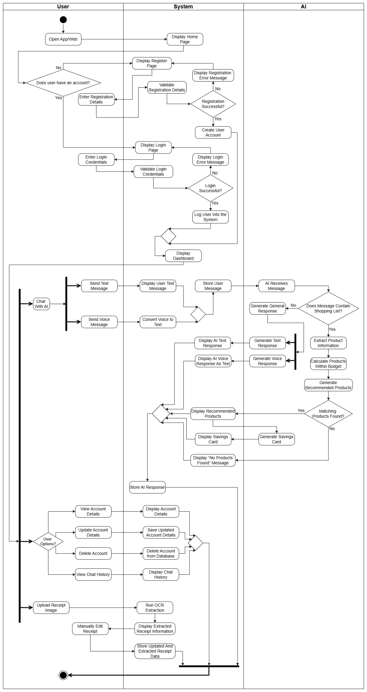

UML Sequence Diagram
The following sequence diagram is a representation of system object interactions during user authentication. This User Authentication sequence diagram is subsequently connected to the User Feature Navigation sequence diagram, which illustrates the system object interaction during user navigation after authentication.
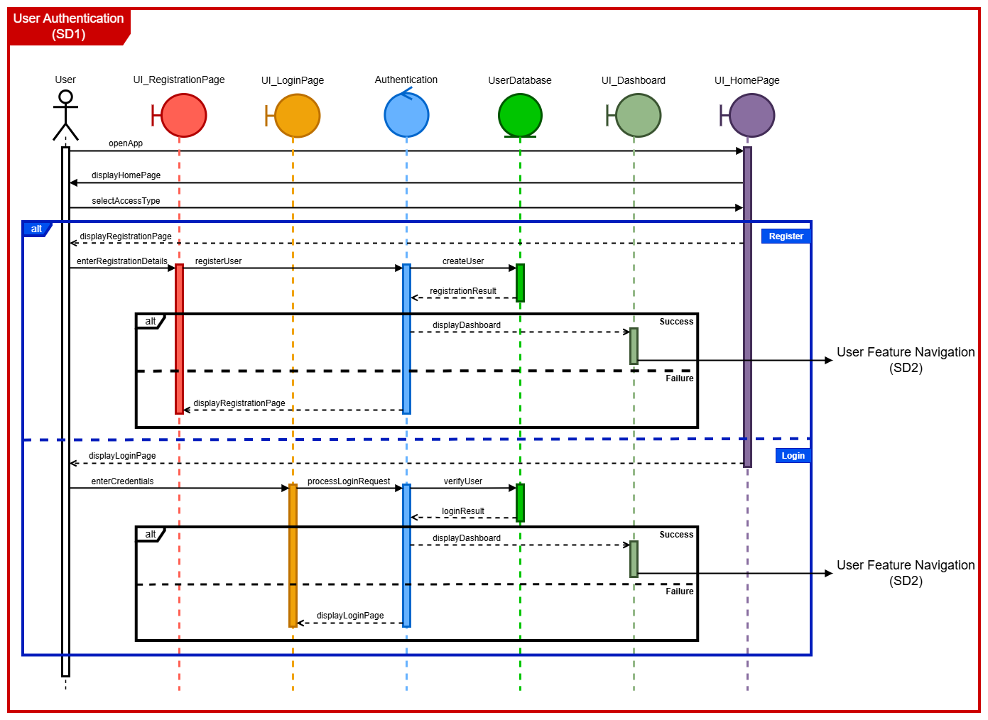

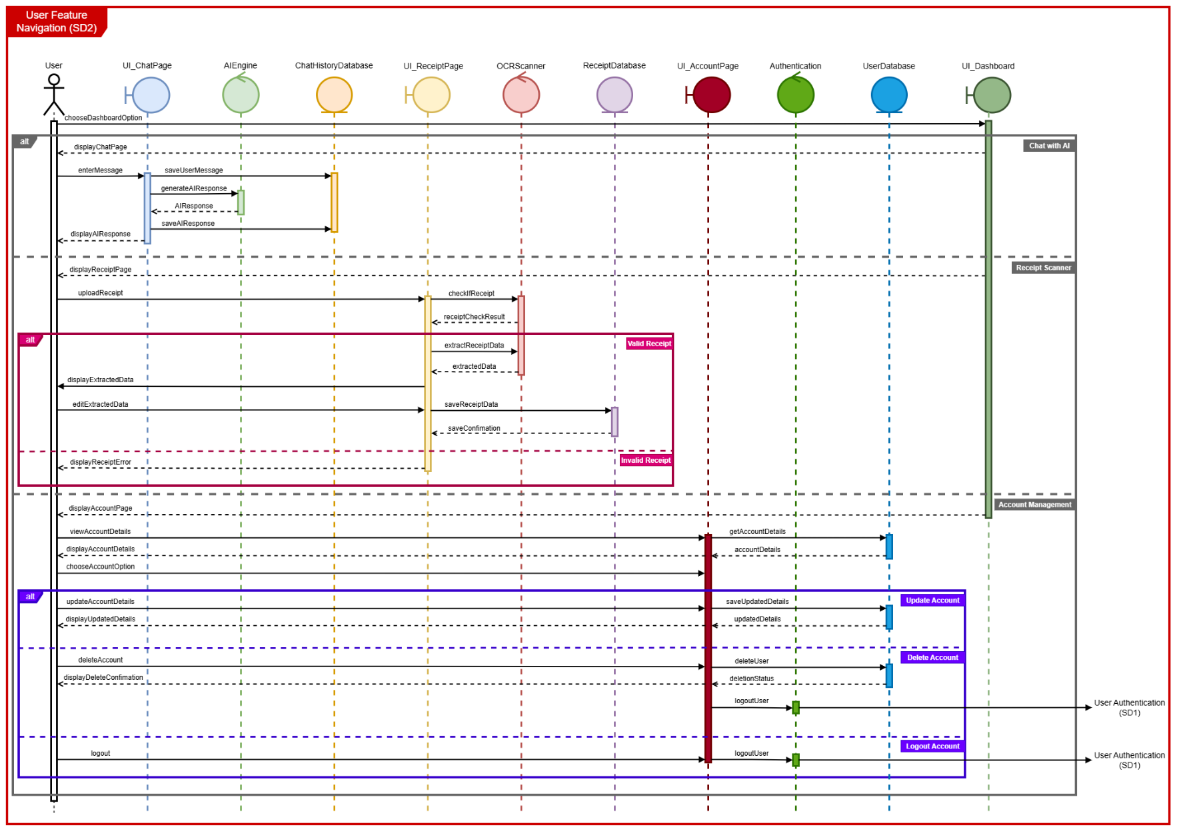

System Actors and Roles
This section identifies all stakeholders that interact with your system, and what they do.

Actor / Role | Description | Frequency of Use | Permissions / Responsibilities | Additional Notes
User who has created account (Registered User) | A registered User is a user who creates an account using an email and password so everything they use/add is saved. | Frequently | Create their account, add a shopping list, add budget, have a conversation with AI agent, view chat history with AI agent, upload receipts
AI agent | A web-based interface included an AI agent, which will be able to communicate through text and speech and make recommendations to the user. | Frequently | Analyse receipts, analyse shopping lists, calculate the best combination of stores to stay within budget, generate a response to user
System manager (Admin) | The admin manages the data. | Rarely | Manages the system database like passwords, and updates the system when needed

Dependencies and Impacts
List other systems, software, or processes that this system depends on, and any potential impact on them.

System / Software | Type | Description | Risk / Mitigation
Web Browser | Dependency | The system relies on the user having access to a modern functional web browser. | Risks: The system may not function properly on outdated web browsers. Differences in browsers may affect layouts and features, meaning users may not be able to access all features or have a limited user experience.  Mitigation: Avoid large graphics and files to ensure fast loading times, use standard web technologies supported by all browsers or restrict the system’s supported browsers, include limited features to fall back on.
Web Hosting Server | Dependency | The system’s design heavily relies on a relational database management system to store and retrieve data, including user account data, user preferences, and product and supermarket information. | Risks: the database system experiencing downtime may lead to the system breaking, as users would not be able to authenticate their accounts or use any of the system’s functionality. Data loss could affect the system’s reliability, and corrupted data could lead to inconsistencies and incorrect recommendations. Limited storage capacity may restrict the potential for data growth and affect the system performance.  Mitigation: use a reliable RDBMS. Validate data and apply suitable constraints to protect data integrity. Avoid storing unnecessary data. Regular backups should be performed to mitigate the risk of data loss.
Database Server Resource Usage | Impact | The system will impact the database server by frequently reading and writing data, including user account information, user preferences, chat history and product and supermarket data. | Risks: the large amount of data being written, especially the user’s chat history which will be retained, could put pressure on the server and slow the system’s performance as data grows, leading to slower user experience or usage limits being reached.  Mitigation: limit the amount of data stored and keep chat responses concise to avoid unnecessary storage usage. Include a feature to clear chat history. Use indexing to efficiently handle common queries. Archive old or inaccurate data.
OCR Scanner | Dependency | The system relies on an OCR scanner to extract text from images of receipts and learn product and supermarket information and prices. | Risks: the results may be inaccurate due to poor image quality. Incorrect text extraction would compromise the integrity of the data and, therefore, the reliability of the AI agent, leading to incorrect recommendations.  Mitigation: reject blurry images instead of risking inaccurate information. Before storing the extracted information, validate it. Allow users to manually correct text that may be extracted incorrectly.
Natural Language Processor (NLP)  Spacy | Dependency | The system replies on Spacy a NLP to analyse the user input and extract meaningful information. | Risks: only works for the English language, it will detect slang words as well.  Mitigation: handle edge cases

System Constraints
These are the constraints considered for the system system.

Upload Receipt Constraints
Receipt Scanner currently will detect some lines in the receipt that are not actually items, example weights of item written on next line. There is no way of removing extra items in text field or leaving it blank, so incorrect items are added to database. The image below illustrate this error.





As seen in the above images, the FA currency is written along with product name. The scanner has currently been tested only with a limited number of receipts, so it is uncertain if it will work for all receipts. Additionally, some letters are not detected clearly, however user has option to fix these errors before sending it to the database.

Chatbot Constraints
The function to calculate the cheapest way of purchasing the user’s items doesn’t consider time and fuel spent travelling. The system will suggest going to many stores to save a small amount of money, which may not be realistically worth it to a user. The chatbot function may not handle incorrect spelling and grammar, as well as slang. The chatbot has a narrow intent filter. It assumes requests are genuine shopping items and will still search the database for all requests and may also misclassify things that are not shopping items. However, the system still functions if an item isn’t found and simply informs the user the item is not available. The chatbot only supports requests in English.

Functional Specifications

High-Level Functionalities
These are the main functions the system must perform.
1. User Account Management
1.1 User Registration
1.2 Update Account Details
1.3 View Account Details
1.4 Delete Account
1.5 User Login

2. Data Storage
2.1 Store User Details in Database
2.2 Maintain Product and Store Details in Database

3. AI Agent And User Interaction
3.1 User Input to AI via Text
3.2 User Input to AI via Voice
3.3 AI Text Response Generation
3.4 AI Voice Response Generation
3.5 Chat History Access

4. AI Budget Calculation
4.1 AI Extracts Information from User Input
4.2 AI Calculates Product Recommendations Within User Budget

5. Receipt Scanning
5.1 Receipt Upload
5.2 Receipt Data Extraction via OCR

6. Social Savings Card
6.1 Display Savings Card
6.2 Share Savings Card to Social Media

Use Cases
These are the use cases for the system.

Use Case ID | UC-1
Use Case Name | Register Account
Primary Actor | User
Trigger | User clicks Register
Pre-Conditions | None
Post-Conditions | New account stored in the database
Main Success Scenario | 1. The system collects the user's email and password  2. The system validates inputs  3. The account details are created and stored in a database
Alternative Flows | 1. If the user already has an account, ensure a message stating this is displayed  2. If the password is too weak, ensure the user is prompted to enter it again
Priority | Medium

Use Case ID | UC-2
Use Case Name | Login To Account
Primary Actor | User
Trigger | User clicks Login
Pre-Conditions | User has a ShopQuick account
Post-Conditions | User is authenticated
Main Success Scenario | 1. The user enters credentials  2. The system verifies user credentials in the database  3. The user is logged in
Alternative Flows | If the user enters incorrect credentials, then an error message is displayed
Priority | High

Use Case ID | UC-3
Use Case Name | Update Account Details
Primary Actor | User
Trigger | User clicks on the profile icon to manage the account
Pre-Conditions | User has a ShopQuick account
Post-Conditions | Updated details stored in the database
Main Success Scenario | The user can successfully update profile information, location and dietary preferences, and this is added to the database
Alternative Flows | None
Priority | Medium

Use Case ID | UC-4
Use Case Name | View Account Details
Primary Actor | User
Trigger | User clicks on the profile icon to view account details
Pre-Conditions | User has a ShopQuick account
Post-Conditions | None
Main Success Scenario | The user can successfully view profile information, location and dietary preferences
Alternative Flows | None
Priority | Medium

Use Case ID | UC-5
Use Case Name | Delete Account
Primary Actor | User
Trigger | User clicks Delete Account
Pre-Conditions | User has a ShopQuick account
Post-Conditions | None
Main Success Scenario | The user can successfully delete account, and user is removed from database
Alternative Flows | None
Priority | Medium

Use Case ID | UC-6
Use Case Name | User Send Text Message
Primary Actor | User
Trigger | User clicks the send button on the chatbot
Pre-Conditions | None
Post-Conditions | Message stored in database
Main Success Scenario | - The user enters text  - The system displays the message  - The message is stored in the database
Alternative Flows | None
Priority | Medium

Use Case ID | UC-7
Use Case Name | User Send Voice Message
Primary Actor | User
Trigger | User clicks the send button or holds the microphone button on the chatbot
Pre-Conditions | None
Post-Conditions | Message stored in the database
Main Success Scenario | - The user records voice  - The system converts the voice input into text  - The system displays the message  - The message is stored in the database
Alternative Flows | The voice input could not be recognised, so the user is prompted to enter text instead
Priority | Medium

Use Case ID | UC-8
Use Case Name | AI Send Text Response
Primary Actor | AI
Trigger | User has sent a message first
Pre-Conditions | User’s message was received
Post-Conditions | AI response is stored in the database
Main Success Scenario | - The AI generates text  - The system displays the AI response  - The AI response is stored in the database
Alternative Flows | None
Priority | High

Use Case ID | UC-9
Use Case Name | AI Send Voice Response
Primary Actor | AI
Trigger | User sends a voice message first
Pre-Conditions | User’s voice message was received
Post-Conditions | AI response is stored as text
Main Success Scenario | - AI generates a voice response  - The system displays the voice response  - The system stores the AI voice response as text
Alternative Flows | If the AI cannot generate a voice response, a text response will be sent instead
Priority | Medium

Use Case ID | UC-10
Use Case Name | View Chat History
Primary Actor | User
Trigger | User clicks the view chat history button
Pre-Conditions | User has previous conversations with AI
Post-Conditions | None
Main Success Scenario | The system retrieves and display chat history
Alternative Flows | None
Priority | Medium

Use Case ID | UC-11
Use Case Name | Extract User Input
Primary Actor | AI
Trigger | User message contains a shopping list
Pre-Conditions | User sent a message
Post-Conditions | None
Main Success Scenario | The AI identifies products from the user input
Alternative Flows | None
Priority | High

Use Case ID | UC-12
Use Case Name | Calculate Products Within Budget
Primary Actor | AI
Trigger | AI extracted the correct products from user input
Pre-Conditions | None
Post-Conditions | None
Main Success Scenario | - The AI checks the database for extracted product information  - The AI calculates items within budget
Alternative Flows | None
Priority | High

Use Case ID | UC-13
Use Case Name | Display Recommended Products
Primary Actor | AI
Trigger | AI has completed budget calculation from the database
Pre-Conditions | None
Post-Conditions | None
Main Success Scenario | The AI displays products within budget to the user
Alternative Flows | If no products are in range, display a message confirming this
Priority | High

Use Case ID | UC-14
Use Case Name | Upload Receipt
Primary Actor | User
Trigger | User clicks the upload file button to upload the receipt
Pre-Conditions | None
Post-Conditions | None
Main Success Scenario | - The user uploads a receipt  - The system uploads the image  - The OCR starts scanning and extracting the information
Alternative Flows | If the receipt is unscannable, too blurry or unreadable, then the user can manually type out the contents of the receipt instead
Priority | High

Use Case ID | UC-15
Use Case Name | View Extracted Receipt Information
Primary Actor | User
Trigger | Receipt was successfully uploaded
Pre-Conditions | OCR extraction completed
Post-Conditions | Extracted data is displayed
Main Success Scenario | The system displays the extracted receipts information.
Alternative Flows | None
Priority | High

Use Case ID | UC-16
Use Case Name | Manual Editing Receipt Information
Primary Actor | User
Trigger | OCR extraction contains errors
Pre-Conditions | Extracted data is displayed
Post-Conditions | Corrected receipt data is stored
Main Success Scenario | - The user edits any incorrect fields  - The system saves the edited receipt data to the database
Alternative Flows | None
Priority | Medium

Use Case ID | UC-17
Use Case Name | Display Savings Card
Primary Actor | AI
Trigger | AI generated product and store recommendations
Pre-Conditions | None
Post-Conditions | Savings card displayed with options to upload on social media
Main Success Scenario | - The AI generates a savings card  - The system displays the savings card
Alternative Flows | None
Priority | Medium

Use Case ID | UC-18
Use Case Name | Upload Savings Card
Primary Actor | AI
Trigger | Savings card displayed
Pre-Conditions | Savings card generated
Post-Conditions | Uploaded to the desired social media platform
Main Success Scenario | - The user chooses a social media platform to upload their savings card on  - The system confirms upload actions
Alternative Flows | None
Priority | Low

Functional Requirements
The following table describes the functional requirements and their priority level.

Req ID | Requirement Name | Description | Priority
1.1 | User Registration | The system will allow the user to register by creating an account using an email and password. | Medium
1.2 | Update Account Details | The user can update dietary preferences, location, password, email, etc. | Medium
1.3 | View Account Details | The user can see their preferences and account details. | Medium
1.4 | Delete Account | The user can delete their account, including an option to delete saved data. | Medium
1.5 | User Login | The system will allow the user to log in by entering the registered email and password. | High
2.1 | Store User Details in Database | All account information about ShopQuick users is stored in the database. | High
2.2 | Maintain Product and Store Details in Database | Any new information about product and store details is added to the database. | High
3.1 | User Input to AI via Text | The user can utilise the chat function via text. | High
3.2 | User Input to AI via Voice | The user uses the microphone functionality to speak to the AI agent. | Medium
3.3 | AI Text Response Generation | The AI responds to the user in text format. | High
3.4 | AI Voice Response Generation | The AI responds to the user in voice format. | Medium
3.5 | Chat History Access | The user can view their chat history of the previous conversations with the AI agent. | Medium
4.1 | AI Extracts Information from User Input | The AI agent retrieves the exact products and budget from users’ input. | High
4.2 | AI Calculates Product Recommendations Within User Budget | The AI agent searches the database against the user’s input and calculates the most cost-effective combination of stores to get each item. | High
5.1 | Receipt Upload | The user can upload an image of a receipt to aid data collection. | High
5.2 | Receipt Data Extraction via OCR | The receipt data is extracted using OCR and information like store location and product details are added to the database. | High
6.1 | Display Savings Card | After AI generates and optimises a list, a card showing the savings will appear. | Low
6.2 | Share Savings Card to Social Media | The savings card can be uploaded to social media. | Low

UML Use Case Diagram
The following use case diagram represents the system’s functional requirements and the associated use cases.
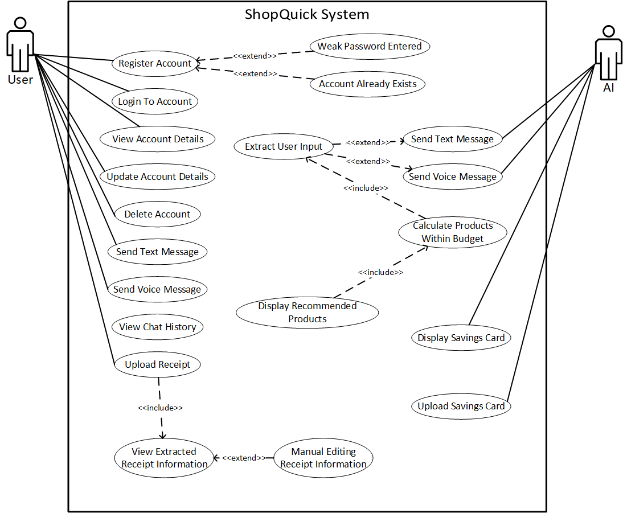

Testing / Acceptance Criteria
The following table defines how each functional requirement will be verified or tested.

Req ID | Requirement Name | Test Scenario | Expected Output
1.1 | User Registration | The user creates an account, logs out, and attempts to log back in using registered details. | Once logged in successfully, the user can see their account name on the chatbot dashboard.
1.2 | Update Account Details | The user logs in, updates dietary preferences, location, email, and password, then logs out and signs back in using the updated credentials. | The new information is saved and will be available on their dashboard at the next login.
1.3 | View Account Details | The user logs in and navigates to their account page from the dashboard. | The user information can be seen clearly on the account page.
1.4 | Delete Account | The user clicks delete account on account page. | The page refreshes, and the user is signed out of the account.
1.5 | User Login | The user enters the credentials provided at registration to log in. | The user is logged in successfully and the dashboard is displayed.
2.1 | Store User Details in Database | The admin accesses the database after a new user is registered. | The admin can see the new user login and account details in the database.
2.2 | Maintain Product and Store Details in Database | The admin accesses the database after new products and store details are added. | The admin can see the new product and store details in the database.
3.1 | User Input to AI via Text | The user types in the text area provided on the chatbot and presses send. | The typed text appears in the chat interface with a timestamp.
3.2 | User Input to AI via Voice | The user clicks on the microphone button, speaks and then stops recording. | The system records voice input, converts speech to text, and displays transcribed text in chat with a timestamp.
3.3 | AI Text Response Generation | The user submits a shopping list and budget via text. | The AI generates a calculated shopping list of the cheapest options.
3.4 | AI Voice Response Generation | The user submits a shopping list and budget via voice. | The AI generates a calculated shopping list of the cheapest options, but responds in voice format, and transcribed text is also shown on screen.
3.5 | Chat History Access | The user clicks sidebar, that shows chat history | The chat history from all previous conversations is shown.
4.1 | AI Extracts Information from User Input | The user types or records the budget and shopping list to the AI agent. | The AI should send a message confirming these details, then proceed to the budget calculation functionality.
4.2 | AI Calculates Product Recommendations Within User Budget | The user types or records the budget and shopping list to the AI agent. | The AI indicates where to find items nearest to the user and within budget.
5.1 | Receipt Upload | Three types of receipt are uploaded:  1. Low quality receipt  2. Average quality receipt  3. High quality receipt | A message should appear informing the user that the receipts have been successfully uploaded and accepted.
5.2 | Receipt Data Extraction via OCR | Once a receipt is uploaded, wait for extracted data to be displayed. | The OCR correctly extracted the receipt data, allowing the user to edit any information displayed.
6.1 | Display Savings Card | The AI complete optimisation of a shopping list provided by the user. | A savings summary card appears automatically, displaying the amount saved.
6.2 | Share Savings Card to Social Media | The user clicks the share option on the savings card. | The savings card is uploaded to the chosen social media platform.

Non-Functional Requirements

Performance Requirements
The performance requirements ensure that the ShopQuick web application is instantaneous and responsive, enabling a smooth user experience.
  - Response Time: The system should load all pages and AI responses within 2 seconds.
  - Throughput: The system should maintain a stable performance by supporting multiple simultaneous user interactions.
  - Capacity: The system should support up to 20 simultaneous users without performance deterioration.
  - Database Performance: The system should retrieve and store user data in the database within 1 second.

Security Requirements
The security requirements ensure that the ShopQuick web application handles and protects user data responsibly.
- Encryption: The system should store user login details, such as passwords, with secure hashing.
- Authentication: The users must authenticate using email and password to access their accounts.
- Password Reset: The system should allow users to reset their passwords through a secure email verification link.
- Access Controls: Only authenticated users can access account management, AI chat history, preferences, location and receipt uploads.
- Legal Compliance: The system must comply with the GDPR standards when handling user data and privacy.

Usability Requirements
The usability requirements ensure that the ShopQuick web application improves user experience.
- Accessibility: The system should have readable fonts with a consistent colour scheme throughout the different web pages.
- Error Handling: The system should display user-friendly error messages during receipt uploads and AI chats.

Availability / Reliability Requirements
The reliability requirements ensure that the ShopQuick web application is consistent.
- Uptime: The system should always be available.

Additional Non-Functional Requirements
The ShopQuick web application will also include additional non-functional requirements.
- Portability: The system should run on all browsers across all devices.

Testing / Acceptance Criteria
The following table defines how each non-functional requirement will be verified or tested.

Req ID | Requirement Name | Test Scenario | Expected Output
1.1 | Response Time | Use DevTools to check page load time and AI response time. | All pages and AI responses load within 2 seconds.
1.2 | Throughput | Simulate multiple user actions on the web application by using load testing tools like Apache JMeter or Locust. | The system remains stable and responsive with no crashes or freezing.
1.3 | Capacity | Simulate 20 simultaneous users on the web application by using load testing tools like Apache JMeter or Locust. | The system supports 20 simultaneous users without performance deterioration
1.4 | Database Performance | Time database retrieval and storage time using the database's built-in profiling. | Data is retrieved and stored within 1 second.
2.1 | Encryption | Check the columns in the database with user credentials. | Passwords are hashed and not stored as plain text.
2.2 | Authentication | Log in with valid and invalid credentials. | Only users with correct email and password can log in.
2.3 | Password Reset | Click on the password reset and check for the email link. | User receives a verification email, and the email link allows the user to reset the password securely.
2.4 | Access Controls | Attempt to access pages requiring login without authenticating. | Unauthenticated users are redirected to the login page.
2.5 | Legal Compliance | Review the GDPR standards. | System complies with the GDPR standards.
3.1 | Accessibility | Check font, colour scheme and layout across all web pages. | All pages have consistent readable fonts, colours and layouts.
3.2 | Error Handling | Upload large and unsupported file receipts, and enter incomplete chat inputs. | Error messages are displayed with clear instructions.
4.1 | Uptime | Run the web application. | The web application remains available all the time.
5.1 | Portability | Run the website on different browsers on different devices | System runs on all devices and browsers with no glitches or crashes.

Data and Reporting Requirements

Data Sources
The system relies on internal data sources such as user inputs, admin inputs, and system generated data to populate and maintain the database.

The system collects user data via registration and login forms to enable personalisation and generates authentication data. Additionally, product and store details are extracted from receipts uploaded by users. However, the database also contains exclusive data accessible only by admins which includes dietary label definitions. The system also generates data such as timestamps for chat history logs to facilitate conversation tracking.

The system does not rely on any external sources to update or maintain the database.

Data Structures and Entities
For the system, a database called “ShopQuick” was created using MySQL. The ShopQuick database includes four main entities and two bridge tables to resolve the many-to-many relationships. The following are the attributes and the description of each the entities in the ShopQuick database. The products table contains 500 AI generated products.

Entity Name | Entity Description | Entity Attributes | Entity Source
users | The users table stores and registers user information. The login details will be stored, and each user will be uniquely identified using a user_id. | user_id: this uniquely identifies each user as it is a Primary Key  email: stores each users email given during registration  password: stores a hashed password instead of the plain text to ensure user privacy  user_location: stores the user location that could be accessed by the AI agent for store recommendations  dietary_preferences: stores the user’s dietary preferences that can be accessed by the AI agent for product recommendations | The user inputs the data for this table in the registration form, or the data can be updated in the user account page.
messages | The messages table stores the user and AI agent conversations. The message table stores any message linked to a specific user to enable to the chat history feature implementation. | id: uniquely identifies each message as it is a Primary Key  user_id: this ensures the message belongs to a valid user as it is a Foreign Key that references user_id from the users table  role: this is an enumerate attribute that can either be “user” or “agent”, and it is utilised to identify the message sender.  content: this stores the message content as plain text  created_at: This stores the timestamp indicating the time the message was sent | Both the user and the AI agent would be entering data in this table through their text or voice messages in the chatbot.
products | The products table stores the product information. The products table currently contains 500 AI generated products with some repeated products with same sku but different names or brands. | product_id: uniquely identifies each product as it is a Primary Key  sku: it is used to identify the same products under different names in the database  product_name: stores the product name  product_brand: stores the product brand  product_price: stores the product_price to two decimal places  store_id: this ensures that the store already exists in the database, and it is a Foreign Key that references store_id from the stores table  dietary_labels: this stores all the applicable dietary requirements met by the product | The user will upload a receipt and the system will extract the receipt data and store the product information in the products table.
stores | The stores table contains all the information tilted to a store to enable the AI agent to make accurate store recommendations. | store_id: uniquely identifies each store as it is a Primary Key  store_name: retains the store name  store_address: retains the store address  store_postcode: retains the store postcode  store_city: retains the store city | The user will upload a receipt and the system will extract the receipt data and save the store information in the stores table.
dietary_labels | The dietary_labels table contains various dietary requirements, allowing the AI agent to recommend appropriate products based on the user's dietary needs. | id: uniquely identifies each dieteray label as it is a Foreign Key  label: stores the label name | The admin can add or remove any dietary label.
user_dietary_map | The user_dietary_map is a bridge table to resolves the many-to-many relationship between the users table and the dietary_labels table. This is because a user can have multiple dietary requirements. | user_id: this ensures the dietary requirement belongs to a valid user as it is a Foreign Key that references user_id from the users table  dietary_id: this ensures the dietary label already exists in the database as it is a Foreign Key that references id from the dietary_labels table | The user_dietary_map table automatically updates once the users table or the dietary_labels table is updated. So, no direct input is needed.
product_dietary_map | The product_dietary_map is a bridge table to resolves the many-to-many relationship between the products table and the dietary_labels table. This is because a product can satisfy multiple dietary labels. | product_id: this ensures the product already exists in the database as it is a Foreign Key that references product_id from the products table  dietary_id: this ensures the dietary label already exists in the database as it is a Foreign Key that references id from the dietary_labels table | The product_dietary_map table automatically updates once the products table or the dietary_labels table is updated. So, no direct input is needed.

Database Design and ER Diagram
The following is Entity-Relationship (ER) Diagram and the table illustrate the primary and foreign keys of each table. All the relationships between the tables are one-to-many relationships.
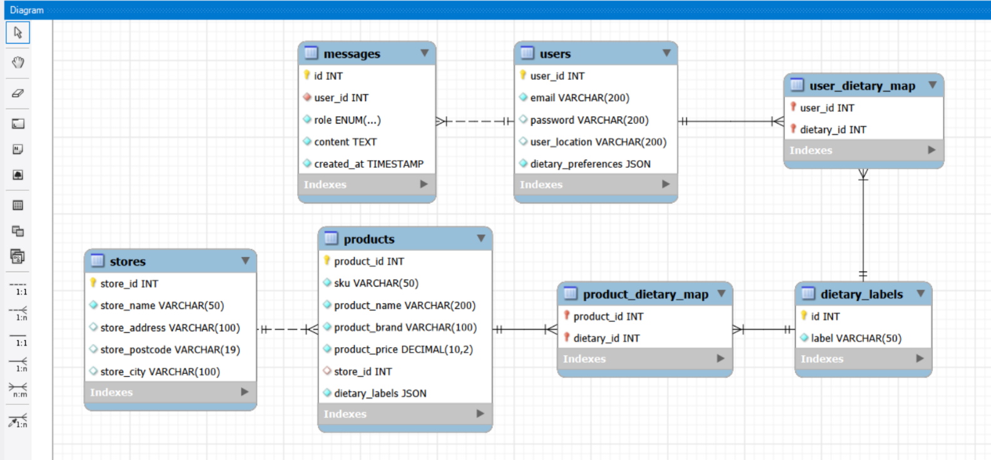

Entity Name | Primary Keys | Foreign Keys
users | user_id | None
messages | id | user_id
products | product_id | store_id
stores | store_id | None
dietary_labels | id | None
user_dietary_map | None | user_id  dietary_id
product_dietary_map | None | product_id  dietary_id

User Interface Design

Interface Overview
The system provides a simple and intuitive interface to register, login, chat with the AI, and upload receipts.

Interface Layout
Here is the initial layout of the key pages.

Chatbot Page
This is the chatbot page where you can interact with the AI and ask it to find the best deals.

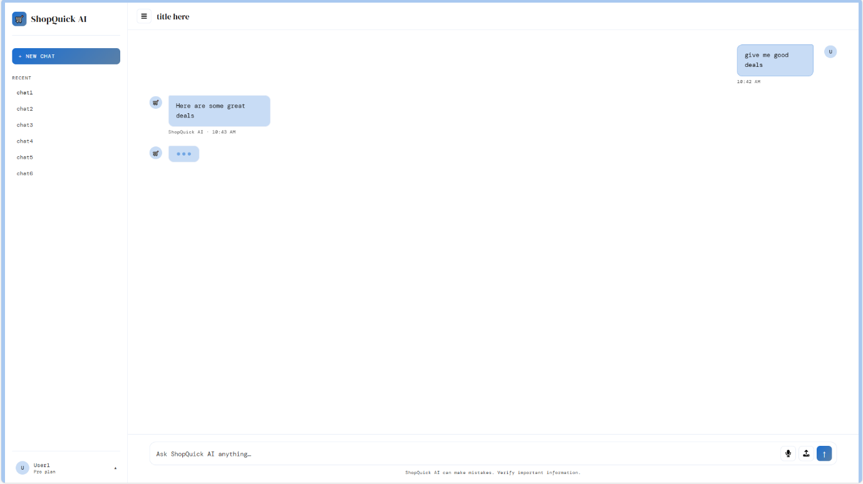

At the bottom is the input bar where the user can type questions to the AI. On the far right, there is a microphone button that allows the user to record voice, which is converted to text. The main purpose of the microphone feature is to enable the user to still interact with the AI chatbot when they are unable to type, for example, when driving. A file button next to the microphone is also included, so that the user can upload receipts and images for it to read and analyse.

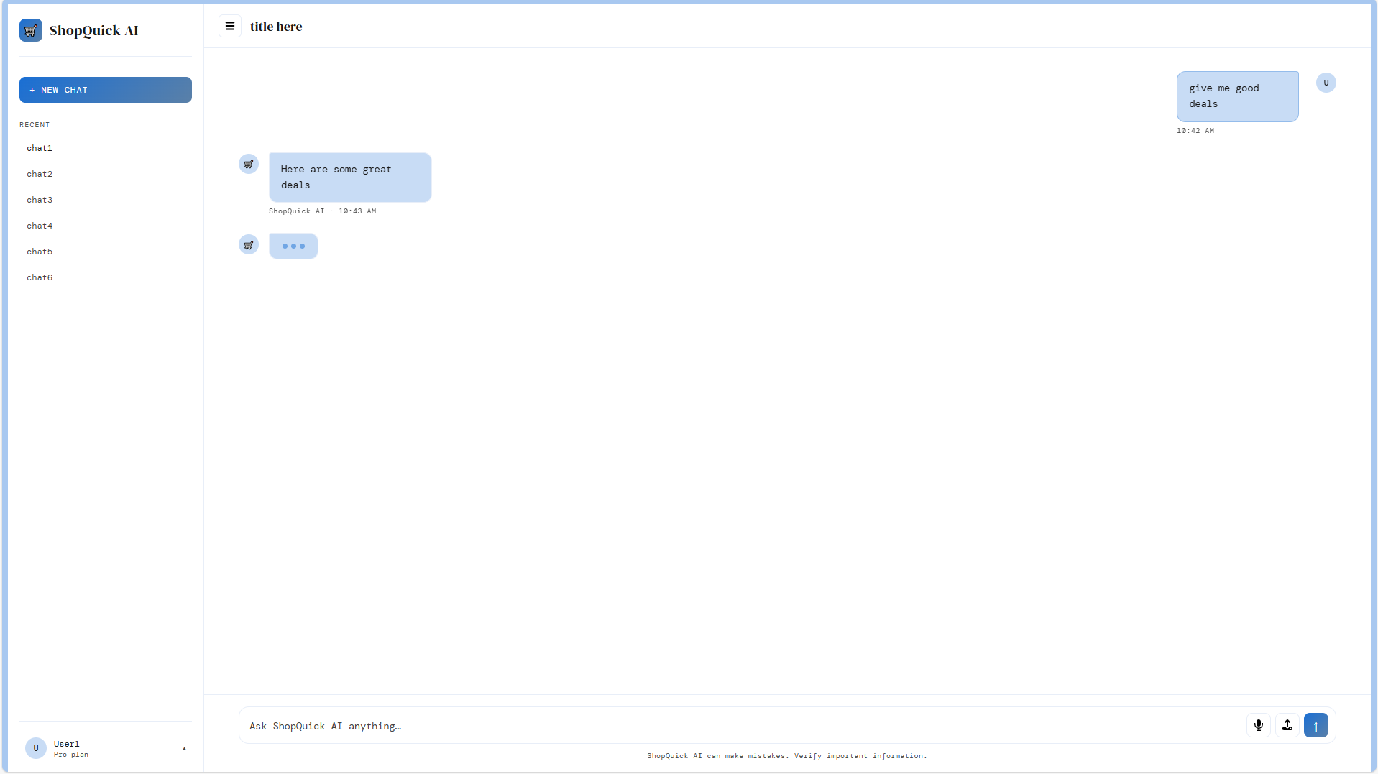

On the sidebar, there are the saved chat histories with the AI, allowing the user to switch between threads or start a new one.

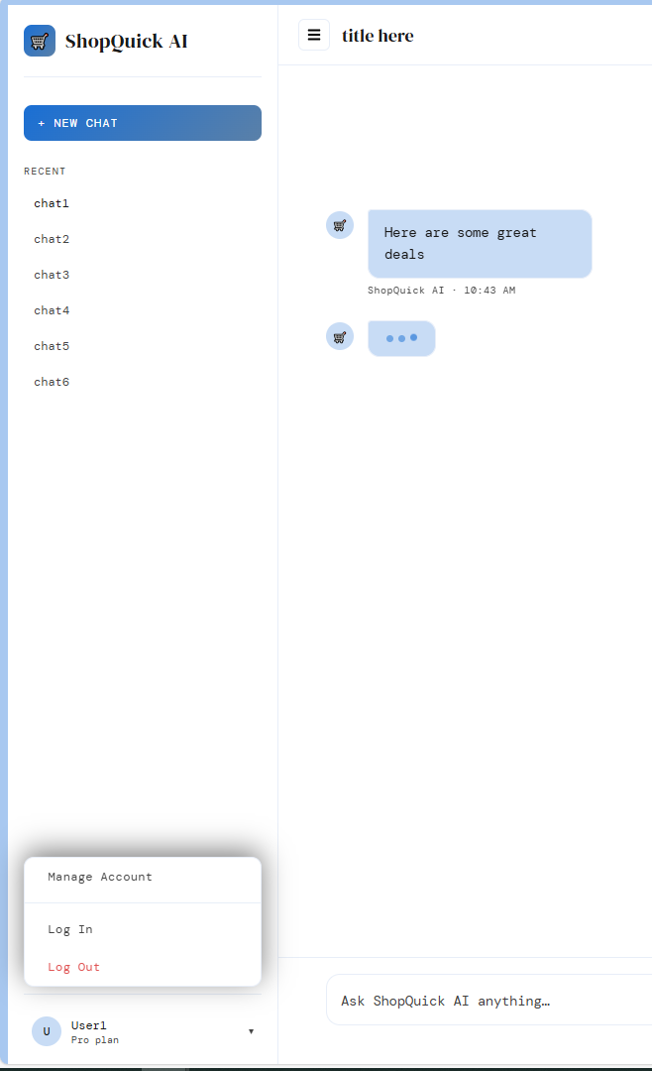

At the bottom left, there is a profile icon and clicking it will display options to login, logout and manage account settings.

New Chat Page
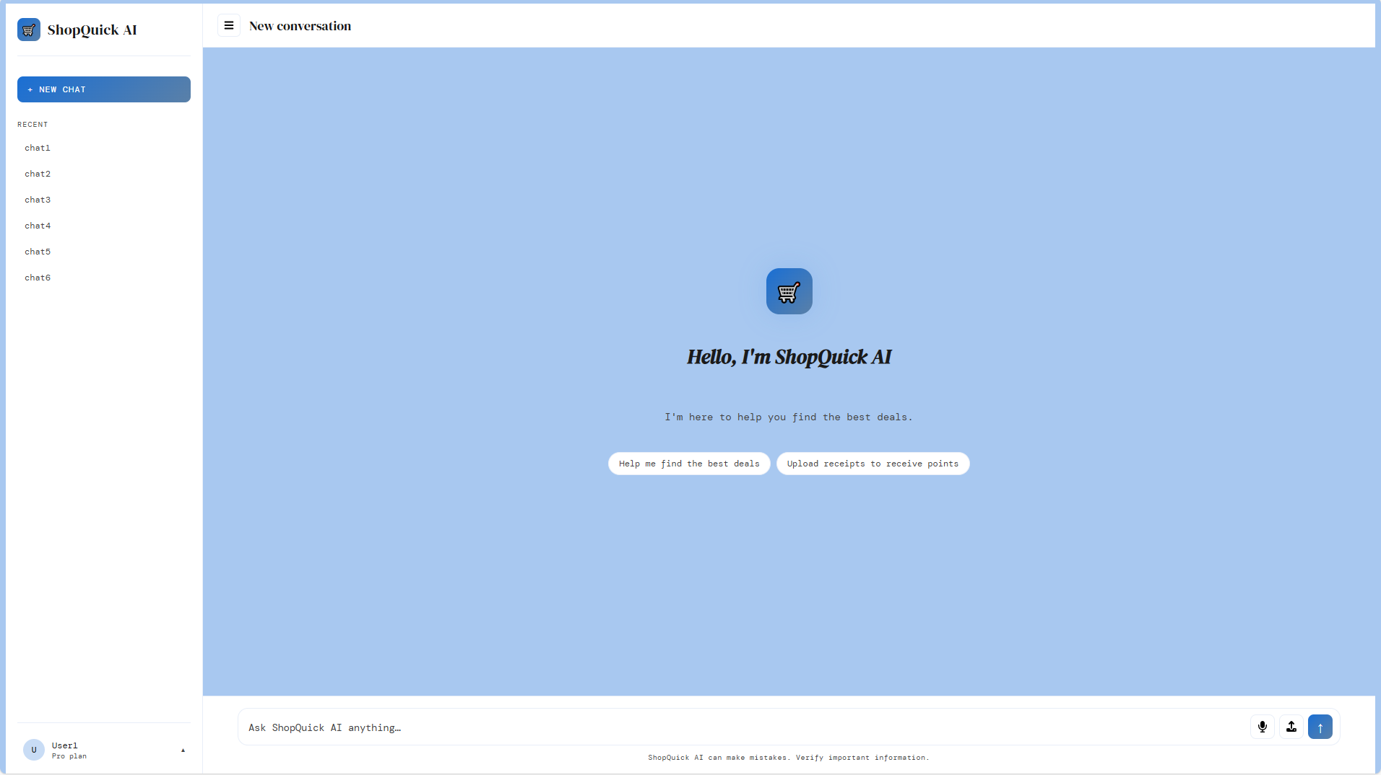

Clicking the new chat in the top left opens a new chat thread and provides a few basic prompts the user can click instantly without typing or speaking.

Receipt Scanner Interface
After scanning the receipt, the receipt is uploaded to the user interface, where the user can input any missing fields not shown on the receipt, or correct wrongly identified items. The confirm and save button will upload this to the database.

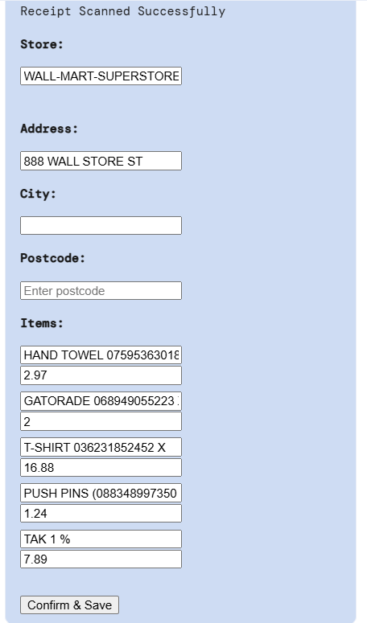

The AI Chatbot Extracting Input and Calculating Cheapest Products
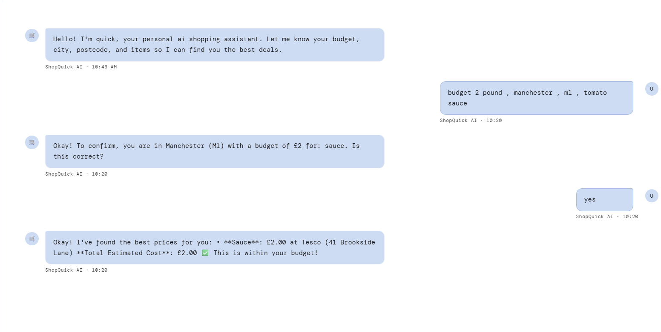

An automated message is shown prompting the user to enter their budget, city and postcode. The AI sends a response confirming user’s input. Products within budget are shown to the user.

Login and Sign-Up Page
User can enter details and then log in . The link at the bottom takes users to the sign-up page if they don’t have an account. The sign-up page takes users to the login if they have an account.

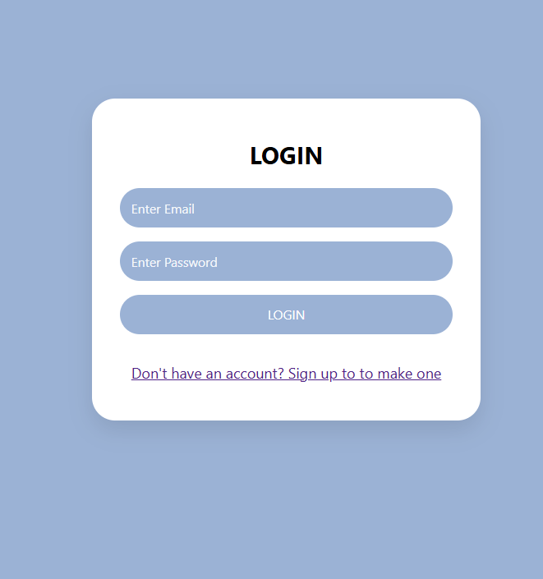

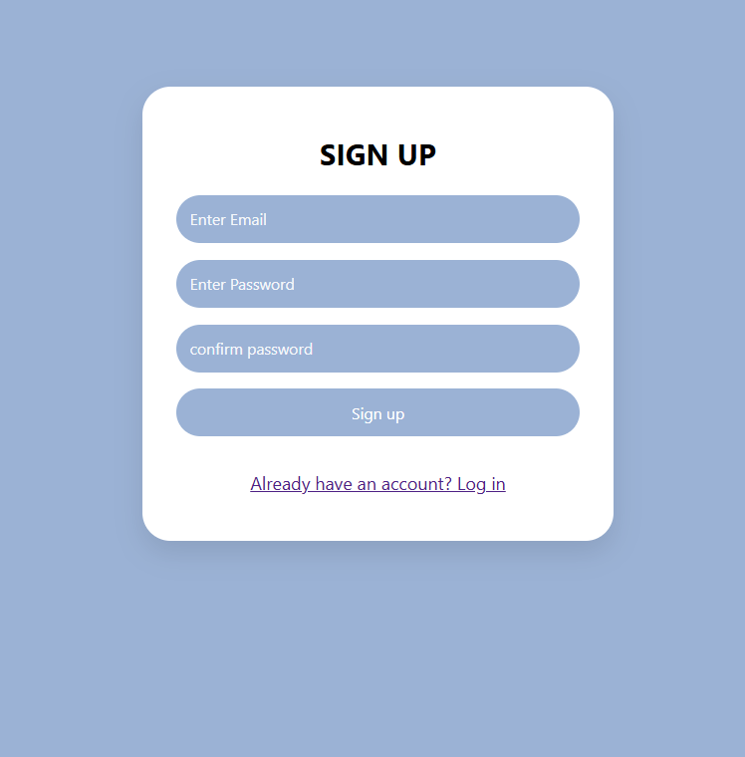

Work Plan and Project Management

Project Development Methodology
The project adopts an Agile methodology with weekly goals, continuous feature integration, and regular documentation updates. Parallel development was practiced by running frontend and backend tasks concurrently to accelerate progress.

Project Timeline and Gantt Chart
The timeline below outlines the project's weekly goals and objectives.

Week | Tasks | Deadline
Week 3 | 1. Attend the client meeting  2. After the client meeting, create an initial requirements document and send it to the client | None
Week 4 | 1. Assign members sections of the Software Requirements Document to be completed by the deadline  2. Make an initial interface layout | Deadline Week 5
Week 5 | 1. Project coding begins.  2. Some members are given backend functionalities:  - Receipt Scanner  - AI Chatbot Communication  - Budget Calculation  3. Other members are given frontend functionalities:  - Login Page  - Sign-Up page  - Chatbot Layout | Deadline Week 7
Week 6 | 1. Implement consistent design and layout across chatbot, login, and sign-up pages  2. Create project diagrams  3. Start considering issues to be documented for the LSEPI of the project  4. Start connecting the frontend and backend using the Flask framework | Deadline Week 7
Week 7 | 1. Finalise extracting user input functionality  2. Ensure frontend and backend are connected  3. Ensure chatbot messages are saved to the database  4. Create a frontend for the social savings card  5. Update documentation with LSEPI, data description, and system context  6. Complete a literature review  7. Sign the NDA  8. Screenshot interface layout and explain functionalities | Deadline Week 8
Week 8 | 1. Check final documentation  2. Organise GitHub repository  3. Submit Specification Document and Prototype | Deadline Week 8
Week 9 | 1. Attend prototype presentation | Deadline Week 9
Week 10 | 1. Start implementation remaining functionalities:  - View Chat History  - User and AI communication via Voice  - User Account Management  - Connecting Savings Card to Chatbot  2. Test the final sytem | Deadline Week 12

The following Gantt chart illustrates the completed weekly tasks

Legal Social, Ethical, and Professional Issues (LSEPI)

Legal Considerations
The ShopQuick system processes user personal data and images, therefore the system must comply with UK General Data Protection Regulation (UK GDPR) and the Data Protection Act 2018. This compliance requires informing the user about how their personal data from the chat history, account pages and receipt uploads is used in the system. This ensures that the data collected for personalisation is not repurposed for unrelated activities without explicit consent. And when the user is interacting with the system, especially during receipt extraction, the system should not collect unnecessary personal data that is not used within the system, as this can lead to data mishandling. Therefore, to avoid data mishandling, the user has the right to access, change and erase their data from the system.
Failure to comply with these legal obligations may result in regulatory penalties and loss of user trust.

Ethical Considerations
Ethical issues may arise from the system’s use of AI, personalisation and data extrusion. Therefore, algorithmic transparency is essential to ensure that users understand that the AI recommendations are generated using synthetic data rather than real-time supermarket databases. This means the users should be informed of their role in the data collection, as their chat history and receipt uploads are the main source of the synthetic data. Consequently, the system should respect user autonomy, allowing users to retain control over their data with no pressure to share their data or promote the application on other platforms. And as the system database also includes dietary requirements which may correlate with cultural or religious affiliations, the system treats all entries as individual needs to ensure an inclusive service without making assumptions about a user’s background.
The system’s design should support users without exploiting their data.

Social Impact
The ShopQuick system is intended to have a positive social impact by supporting users to manage rising living costs through budget-friendly recommendations, which enable users to make informed choices in their day-to-day grocery shopping. And the system enhanced AI input features, such as voice conversation, ensure that even users with limited accessibility can benefit from the ShopQuick AI system. And as the user also contributes to the data collection by uploading receipts, it allows the system to stay updated, accurate and relevant to the current consumer environment. However, this type of data collection can also lead to data inequality if users do not upload receipts or engage frequently with the system. Furthermore, there is a risk over reliance on the AI system, where the user blindly follows recommendations without verifying the AI generated information.
Therefore, the ShopQuick system is designed to assist users rather than the system dictate their choice, and the system should encourage the user to verify any generated information, as this provides transparency and consistency in the system.

Security Considerations
The ShopQuick system handles sensitive personal data and receipt uploads, suggesting that security measures are essential to the system’s performance. Firstly, during authentication, user accounts must be protected with data encryption, secure password hashing and session management. And the OCR processing must prevent malicious file uploads that could lead to data corruption or malware in the database.
Therefore, the system should ensure user privacy and security by safeguarding sensitive information and delivering a reliable user experience.

Professional Responsibilities
The ShopQuick system developers must adhere to the professional standards such as the BCS Code of Conduct. These professional standards involve developers’ competence, integrity and accountability. The developers must ensure that the system is developed with proper testing, documentation and code review. This includes not misrepresenting the system’s accuracy and performance, and respecting user privacy by carefully handling user with transparency. The standards also obliges developers to be accountable and take social responsibility for any system defects and ensure that any errors or concerns are resolved promptly.

